Discussion Questions: Investing in TUFS
Student’s Name
Institutional Affiliation

Discussion Questions: Investing in TUFS
The Problem of TUFS
The Technical Underwriting Financial System (TUFS) was anticipated to bring and benefits to the Northern Insurance Company, however, the problem is that there has been continuous loss more than benefits. The system has tremendously failed the Company since it does not reflect on the changes that are supposed to be done. This is causing the Company millions to fix the issue that they think is causing the failure. According to McKeen and Smith (2005), TUFS idea was to improve the Northern Insurance Company operation system processes to new technology. It was also to change the manual underwriting process with the new underwriting process. Consequently, the process in place does not prove helpful and beneficial for the company. McKeen and Smith (2005) demonstrate that Northern Insurance Company has invested almost $ 4million to fix the system. But the problem does not seem to be with the TUFS. The Company management has the problem which is resulting in the failures of the system. The Company lacks coordination between the stakeholders. In the making of the system, there are two responsible teams that are supposed to be having the coordination for the system to operate effectively.
There are the developmental team and underwriting team; the two teams in Northern Insurance Company lack coordination that caused the problem of underwriting failure. The underwriting team does not coordinate with the developmental team to examine and find the problem. This is because the problem lies with the change of value which the system does not update. Focusing on the problems that may cause a failure in company coordination is one. These are internal factors that lead to failures or success of a company. Internal factors are important because they drive the corporate culture and organizational processes. Northern Insurance Company management seems not to be involved in its internal factors which have a drastic outcome for the company. To avoid the ongoing problem, the company should focus on to fix its internal problems like promote coordination in the teams involved. This will fix the problem in all sets of the company’s endeavors. A successful business depends on the involvement of all stakeholders. In the case where there is a consultative dialogue between the stakeholders, it is easier to identify places of the problem and fix. Moreover, the company should have a short target and procedural plan that ensure the plan is implemented and successful. TUFS also had the problem of review of its system to make the required changes, thus, Northern Insurance Company should make reviews of the work done to ensure the intended outcome is achieved. But this will be successful when the company management realizes the importance of inclusion and promotion of teamwork in the company’s process. The different teams in the company should embrace coordination and cooperation and the importance of each team in the company investments.
How to Realize the Projected Benefit of TUFS
TUFS investment had greater benefits to the company that the Northern need to work on various things to ensure that projected benefits are met. Working with this system was projected to help the company in saving which would benefit the financial process of the company. According to McKeen and Smith (2005), TUFS would place Northern Company at the top position in e-Commerce. This is one thing that the company should be concentrated on to ensure that this system works. The benefit of the system is to put the company at the topmost in the use of e-commerce application. This means no matter what Northern needs to exhaust all the loopholes that result in the failure of the system. The reason is to help the company meet the anticipated outcome of the project from the first place. The system is beneficial for the company and it does not need to be replaced by another system. This is because it can help in value assessment; however, it has been a problem for the company. Martinsou and Killen (2014) acknowledge that value assessment is critical which requires standard strategies to accomplish. Northern need to realize having good value assessment will help to avoid the issues of failures of the system.
The system is capable of working right, only that the strategies of the company are not allowing the system to operate as needed. Another thing the company needs to realize is that the system opens a platform for savings for the company. The company needs to automate the system for its work effectively. This will help the company to reduce its wage bill, hence, saving as anticipated. The company will be able to cut down some of its employees. This is a long time solution for the company since it benefits the company. However, this cannot be met by the company since the system is still under the control of the employees who also do not effectively run the system. As a result, the company continues to invest more on TUFS than it should be helping in saving the company.
The system operation should be conveyed to the whole team of the company. Its importance and anticipated benefits should be made clear to the other employees. This is another thing the company needs to realize. The importance of the knowledge of the employees and involved teams in the system improves the knowledge of the system’s worth. This will help Northern with the issue of inclusion of stakeholders. When the teams have the knowledge and the ability to use the system it will be easier to acquire the needed benefits of TUFS. It is a new application that the teams do not have the clear and vivid technique and knowledge about. This makes it hard for the teams to realize what is at stake.
How to Measure the Benefits
There are various things that should be involved in the case of measuring the benefits of any project to companies. Northern has different factors that are at stake to measure its benefits. The measures are not only based on the financial benefits but have to consider all the factors like time, budget and the task of the project. First, Northern can measure TUFS benefits through evaluation of the budget spent on the project. The budget is useful to determine the benefit that the project is likely to promulgate. Northern should have Key Performance Indicators (KPI). Will (2015) asserts that KPI helps a company to acknowledge its projects performance. This will help Northern to measure TUFS performance which will assist to locate and establish the probable benefit of TUFS. The figure below shows how KPI can assist a company in the cases of unexpected problems.
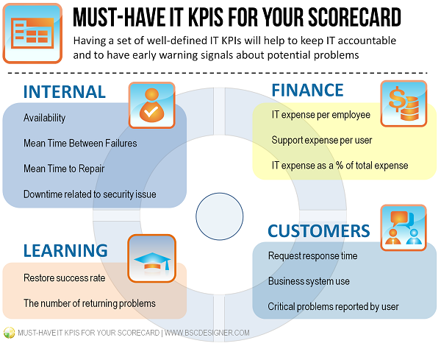 Figure 1: Key Performance Indicator to measure probable problem (Sources: Google.com)
Northern can also measure the benefit of TUFS with the size and performance of the company. In the case that the size of Northern dominates the market, the benefit of TUFS will be high. This means that the anticipated benefit of TUFS will be met. However, if Northern stand in the market is low then it the benefit of the system is likely to be down from what is expected. The performance of the company is also based on the clients that the Company serves. According to Will (2015), clients serve an important role in the performance of any company. Northern will be able to measure its potential and the benefits of the system through its services to the clients. As an insurance company, its services to the clients should be outstanding. This is will help the system to generate perfect and needed benefits to the company. Besides company services, performance and setting Key Performance Indicators (KPI), Northern can use the little tasks that TUFS performs. As the CIO Martin projected TUFS was to give the company the help of savings and reduce the budget of the company. If Northern can focus on the small tasks that TUFS has performed, it can measure the ability of the system. According to Will (2015), the benefits are measured based on the performance and the budget.
There are situations that TUFS have worked and performed for the company. It is these tasks that Northern need to concentrate on to help have a plan for the budget in the system. For what the Company is doing it is not likely to help or benefit the company as needed. This is because instead TUFS reduce the budget the company has continued to spend a lot on the project. McKeen and Smith (2005) show that Northern has kept on investing in TUFS project and continue to incur losses. Northern can only continue to invest in the system in the case that the project is worth the amount. They should not do the investment with a blind eye; hence, they need to measure the performance of TUFS to the budget and the time that is consumed in the process.
References
Martinsuo, M., & Killen, C. P. (2014). Value management in project portfolios: Identifying and assessing strategic value. Project Management Journal, 45(5), 56-70. Retrieved from http://journals.sagepub.com/doi/abs/10.1002/pmj.21452?journalCode=pmxa
McKeen, J. D., & Smith, H. A. (2005). Investing in TUFS. Queens School of Business.
Will, K. (2015). What Should Your Company Measure Besides Financial Results? Balanced Scorecard Institute. Retrieved from
https://balancedscorecard.org/Resources/Performance-Measures-KPIs/What-Should-You-Measure

